#### Inspecting the generated files

What goes for the sensorlist_generated will also count for the other generated files, so we will only discuss this file here.

Open up the sensorlist_generated.html (right-click, open with, Microsoft Office Excel). You will now have the sensorlist but also the column ImportResult filled in. If the field is blank than nothing has changed. Just pay attention to the fields that are colored and have a result in it.

This results can be:

|  |  |
| --- | --- |
| Field | Description |
| Comment | Comment that something is different in the field |
| Changed | Notice that something has changed |
| Failed | Critical failure somewhere in the field |
| Missing | Field tag is missing |
| New | Field is added since last import |

Table 13‑1: Import Result fields

This results will almost always be explained by the same color in the row that triggered the code.

Also you can open the sensorlist_generated_diff.html to see a reference to the same row (the old value that was there before you imported the sensorlist).

#### Comment

Comment usually indicates a minor problem or no problem at all, but you will need to check them. A simple example is that you see the following line:



Figure 13‑15: Comment example 1

If you look further down the row you will see that the problem is the text “bulb nav light SB 1” as you see in the next figure:



Figure 13‑16: Comment example 2

The fact is that “comment” usually indicates that the text is already in use somewhere in the sensorlist. Also it is possible that the field, in this case “AftNavLightSB” is already in use. Use the search function of Excel to find the text throughout the sensorlist.

In this case we will find that the text and the field is also used in line 71 as showed in the next figure:



Figure 13‑17: Comment example 3

You always have to check closely, but in this case it is fairly easy. Line 44 is the status connection as you will find in the SensorType column and it is connected to a DI-module. Line 71 is Standard connection and is connected to a DO-module. As you know how NavVision works this is no problem. With line 71 you can switch the line on and if the light is on it will give a status back on line 44.

Now you now it is no problem and you can leave the row as is.

*: although it is only a comment, do check all fields for abnormalities. If you are sure it is ok, mark it in the sensorlist.*

#### Changed

Changed indicates that there is a bigger problem. It is a warning. It can be that a value has changed in the min/max settings, or an Item-name is changed or even the interface is changed. Eventually something can be changed in either column.

For your convenience NavVision will show the changed cell in yellow as well. So it is easy to look up. It can even be in multiple cells, so have a good look. See the next figures as example:



Figure 13‑18: Changed example 1



Figure 13‑19: Changed example 2

As you can see there is a yellow colored field that will give you the changed value. In these examples it changed the interface. If you are not sure why it is changed or what was there before, you open up the sensorlist_generated_diff.html to see the reference. If we take the second figure as example and we look that up in the sensorlist_generated_diff.html, we’ll see the following:



Figure 13‑20: Changed example 3

Now you can check that in NavVision it was defined as mV in(-125-125). As NavVision knows that a Wago 750-469 slice is a Thermo in (K) slice it changed that interface to the right one.

Now that you know that it was changed because of the right reason, you also will have to change it in your sensorlist to keep that up to date.

*: make sure that you check all the changed fields and adjust them accordingly in your sensorlist. It is not possible with a changed field that you leave one unchanged. They all need to be altered in your basic sensorlist.*

#### Failed

Failed is a critical warning. There is something really wrong in that specific line. It can be anything, from missing information to double sensors. You will have to check the line very carefully. Sometimes it will show a red colored cell to show you what is wrong, but other times you will have to dig deeper to find the problem.

Failed always needs to be rectified in your original sensorlist. Here a simple example:



Figure 13‑21: Failed example 1

This is a sensor on a bus-protocol. As you can tell it was put twice in the sensorlist. Bus-protocols can hang on such information, so it is wise, in this case that you remove the Failed line from your original sensorlist.

#### Missing

Missing is an easy one. In this row the field tag is missing. You can go straight to the Field-column and you will find it is empty. See next figure:



Figure 13‑22: Missing example 1

Find the right field as described in Chapter 11.3.19.1 and put that in the original sensorlist.

#### New

Everything that was changed on board and that wasn’t already in the sensorlist will become visible as new. This could be a new sensor on a Wago, but also a complete new device or interface with, for example a bus-protocol.

The next example is when a new device or interface is connected. You will see the following:

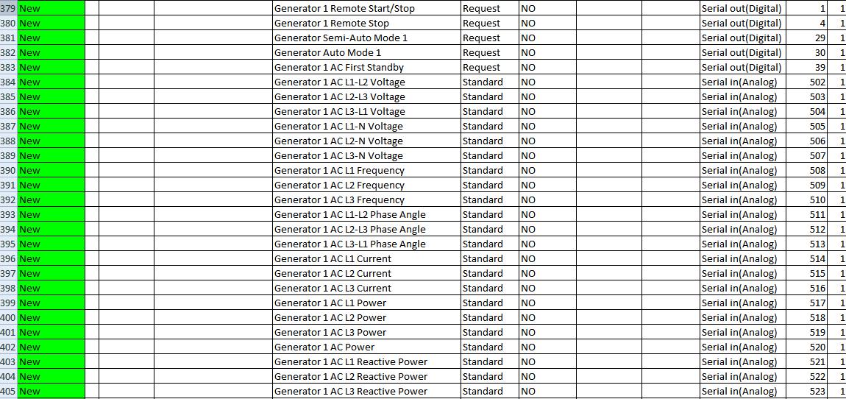

Figure 13‑23: New example 1

You can understand that you have to copy all these lines and paste them into the original sensorlist or they will get lost with a new import.

#### Keep importing

After you checked and replaced all the import results into the original sensorlist, you once again convert it to a sensorlist for import as described in Chapter 9.4 and put it in the root folder of your project folder.

Start NavVision again and import the devicelist and sensorlist. Close NavVision and open the new sensorlist_generated.html.

If you did well there are no more import results except maybe for a few comments that you left there. If not you will have to repeat this process over and over again until there are no more import results and the sensorlist_generated_diff.html is empty.

Once you have reached that point you are finished and your original sensorlist is up to date again.

*: if you arrive on a ship after a long time and the crew has changed a lot, you can follow the same procedures. Just make a backup (or let them send one upfront) and go through all these steps. That way you can start directly with a good and working sensorlist.*